**Assignment 8**

**R-3.8**

No, the tree in the figure is not a (2,4) tree, because all external nodes don’t have the same depth

**R-3.10**

1. 5, 8 , 13, 17, 4, 6

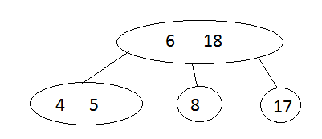

1. 13, 4, 8, 5, 6, 17

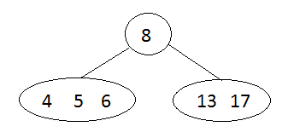

In conclusion, the (2,4) tree structure changes with the order in which the items are inserted.

**C-4.11**

**Algorithm** getWinner(S, C)

Input sequence S containing all the votes

Output the winner Id

H 🡨 create new hashtable 1

Foreach vote Є C do k

H.insertItem(vote,0) k

Foreach vote Є S do n

count 🡨 H.removeElement(vote) n

count 🡨 count +1 n

H.insertItem(vote,count) n

winnerId 🡨 null 1

maxVotes 🡨 0 1

foreach item(c, count) Є H k

if count > maxVotes then k

maxVotes 🡨 count k

winnerId 🡨 c k

return winnerId 1

Total running time is O(n)

**C-4-22**

**Algorithm** findPair(A, B, k)

Input sequence A containing integers, sequence B containing integers, integer value k

Output Boolean value indicating if there a pair (a,b) which sums to k

H 🡨 create new hashtable 1

Foreach v Є B do n

H.insertItem(v, v) n

Foreach a Є A do n

b 🡨 H.findElement(v) n

if b ➢  No_Such_Key then n

return true n

return false 1

Total running time is O(n)